Software Requirements Specification

for

CV4U

**Version 1.0 approved**

**Prepared by :**

**1.David Saal,Liel Harush,Sagi Weizmann,Maria Gerber,Elior Kertsman, Evgeny Shmukler, Karin Gluzman**

**Team Four**

**20/11/2017**

**Table of Contents**

**Table of Contents ii**

**Revision History ii**

**1. Introduction 1**

1.1 Purpose 1

1.2 Intended Audience and Reading Suggestions 1

1.3 Product Scope 1

1.4 References 1

**2. Overall Description 2**

2.1 Product Perspective 2

2.2 Product Functions 2

2.3 User Classes and Characteristics 2

2.4 Operating Environment 2

2.5 Design and Implementation Constraints 2

2.6 User Documentation 2

2.7 Assumptions and Dependencies 3

**3. External Interface Requirements 3**

3.1 User Interfaces 3

3.2 Hardware Interfaces 3

3.3 Software Interfaces 3

**4. System Features 4**

4.1 System Feature 1 4

**5. Other Nonfunctional Requirements 4**

5.1 Performance Requirements 4

5.2 Safety Requirements 5

5.3 Security Requirements 5

5.4 Software Quality Attributes 5

# Introduction

This section gives a scope description and overview of everything included in this SRS document. Also, the purpose for this document is described and a list of abbreviations and definitions is provided.

**1.1 Purpose**

The purpose of this document is to give a detailed description of the requirements for the “CV4U” (CV4U) software.

It will illustrate the purpose and complete declaration for the development of system.

It will also explain system constraints, interface and interactions with other external applications. This document is primarily intended to be proposed to a customer for its approval and a reference for developing the first version of the system for the development team.

## 1.2 Intended Audience and Reading Suggestions

*This document is written for the researchers, software developers, advanced practitioners, documentation writer, and users who involved in domain interface for sorting and organized CVs by differents sections. The rest of this SRS contains the software* Operating Environment, *functions,* Design and Implementation Constraints. In the next sections, system features with their functional requirements are presented to highlight the major services provided by the intended product. Then the external interface requirements highlighting the logical characteristics of each interface between the software product and the users are discussed. Finally, this specification is concluded with the reference documents on which this document is based on.

## 1.3 Product Scope

CV4U is a computer software that provide the HR departments in big companies to get control of the hundreds and even thousands of CVs.

CV4U managing, sorting and filtering through the CVs and help to found the appropriate candidates for specific position. The software allows different departments to be able to provide their input on any given candidate. The software provide the possibility to mark any CV as hired, rejected, postponed or under-review so the candidate can be updated.

Candidates can submit and edit their CVs digitally through the system, and also update with the status of their application.

Furthermore, the software needs Internet connection to update the new relevant requests submitted and the opinions about the candidates written by relevant departments. All system information is maintained in a database, which is located on a web-server.

**1.4 References**

*[1] IEEE Software Engineering Standards Committee, “IEEE Std 830-1998, IEEE Recommended Practice for Software Requirements Specifications”, October 20, 1998.*

*[2] “18 Professional cv templates and examples”. Hloom website,Unknown writer.*

*<http://www.hloom.com/resumes/curriculum-vitae-guide/>*

*[3]- use linkdin CV -Users don’t upload CV to linkedIn,They fill in their profile.*

*What you should be doing, is, after you get the access token, get the user's profile, and fill in your form with relevant fields.*

*This can be helpful:**<https://developer.linkedin.com/documents/profile-fields#fullprofile>*

*You would need r_fullprofile permission.*

*If you don’t need the full profile of the user, see this.* [*https://developer.linkedin.com/documents/profile-fields#profile*](https://developer.linkedin.com/documents/profile-fields#profile)

*[4]*

# Overall Description

## Product Perspective

A new product that allow companies to create a custom template for cv academic.

It is will provide a substitute for a current software for the company in HR(Human Resources) section, different users of the departments in the company have the option to get a view of sorted interface database of specific CV’s that portable to their needs that required from wide and large data base CV’s candidates.

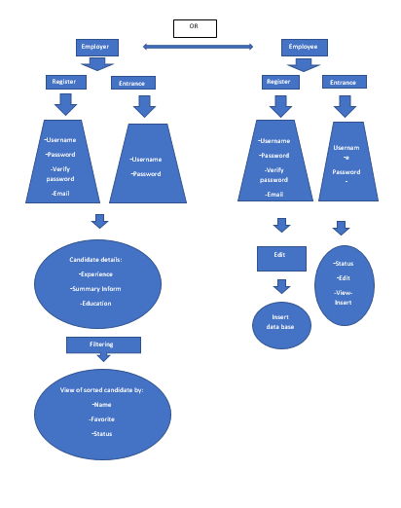

## Product Functions

Keys for the diagram:

1. Rectangle-Defines a button to click , when you click its move to the next frame.

2.Trapeze-Defines the login and register frames with text boxes.

3.Circle-Defines the screen frame.

When the user(employee OR employer),

Enter to our program, he got a few options choice:

Employee Section:The user will get the functionality of this specific choice of registration or entrance. it will show him the register choose to insert his own CV , or edit his current uploaded cv , he can also choose his educational background from a predefined list and login screen .

The login form , and the register form is for recognition , after the login\register screens , he will have the option to, the user also can see the status of his job either is hired\rejected\postponed\under review .

Employer Section: Same functionality as employee at the entrance/register but,

Employer get the filtered CV to his specific demand domain -> Experience,Summary Information,Education

the employer has the option to change his requirements from the candidates,and option to change the CV template by his choice.

## User Classes and Characteristics

There are two types of users that interact with the system: candidates and *HR departments staff*. Each of these two types of users has different use of the system so each of them has their own requirement. the candidates approaching the system through the companie.

The candidates have a few features, to upload their’s CV to the system and to be updated about the CV’s status. The candidate know if he hired, rejected or postponed. furthermore, the candidate can edit his CV any time. Candidates can only approach their own CV and not others. they can only to get access to their own CV.

The HR *departments are managing the overall system. They can filter the candidates according to search domain, hire or reject a request of a candidate and receive an opinions about candidates from various departments who are related to the domain of candidate’s employment.*

*The HR staff who engaged with the program has a security levels. there are employees that have access to all CV records but there are others that can access only their own domain related CVs.*

*Engaging with the program requires basic computer skills, for the candidates only to follow directions and fill the CV template. also, for the companie, there are those who needs to know about all the program and those who need to know only basic function like searching, update, write notes. in general, the program requires basic computer skills.*

*the most important users in the program is the HR staff, they need to know all the features of the program well so they needs to be very satisfied from the program. also, the HR staff anticipated to use the program frequently.*

## Operating Environment

The operating environment of our product is a software which is constrained by the system interface into wide and large database of CV’s which his source contain by the candidate through the website of the company (by mail).

Since the system works on online platform which contain details about the user of the software .

the internet connection is also constraint for the usability of the product.

in additional the operating system will set on two servers, one that contain all the database of the product and the second for a backup.

## Design and Implementation Constraints

The Internet connection is also a constraint for the system. Since it fetches data from the database over the Internet, it is crucial that there is an Internet connection for the system to function. it’s could be a constraints for the candidate that try to upload or edit his CV and also for the companies that need to update with the new CVs and update CVs status.

The system will be constrained by the capacity of the database. it may be forced to queue incoming requests and therefore increase the time it takes to fetch data.

There are some constraints about programming with CLI. the programmer can’t see how the system would look like, he is only working with command line and doesn’t have visual on what he is programming..

## User Documentation

All documentation will be made in accordance with requirements pertaining to open source software under the GNU General Purpose License. Additionally, on-line user documentation will be in the form of **website**.

## Assumptions -

-all the interference is written in english .

- access to the web connection for get access to the data.

- only CV’s from academic world,is acceptable.

-CV Maker API allows developers to integrate its CV builder service .

-optionality to have a server cloud which save the data on it.

-The program aloud to create CV’s by a build-in template that the user will choose.

-The CV’s will be editable.

# External Interface Requirements

## User Interfaces

A user of the software should see the select page when he opens the program.

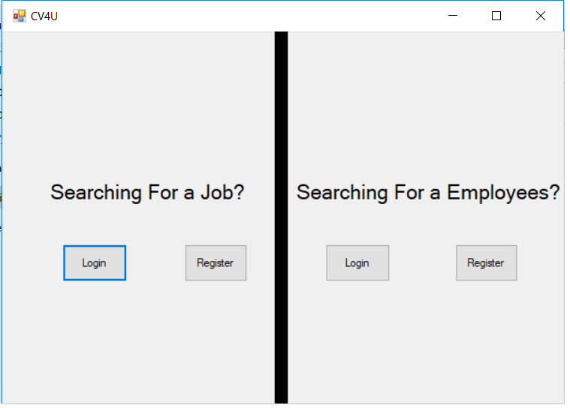

then, he selecting if he searching for a job or searching for employees. If the user has not registered, he should be able to do that on the register page.

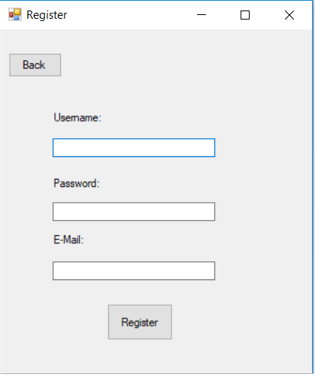

If the user is not a first-time user, he is should go to log-in page:

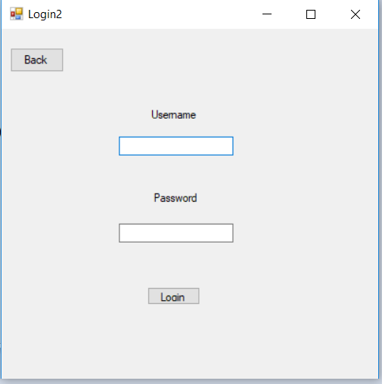

If the user looking for a job he will receive the page where he be able to fill insert CV, edit CV and check the status of his CV.

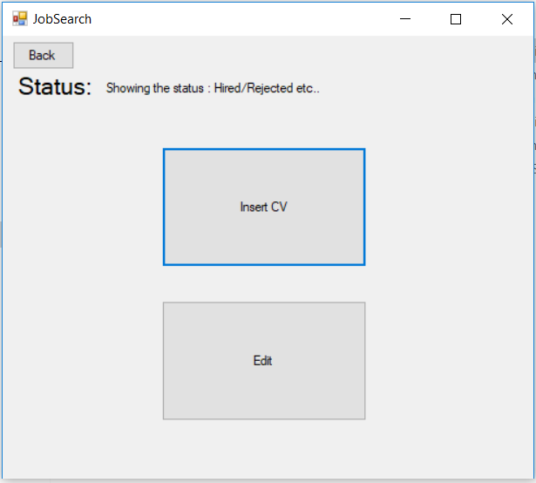

If the user looking for a employee he will receive the page where he be able to create CV ,edit CV and filter.

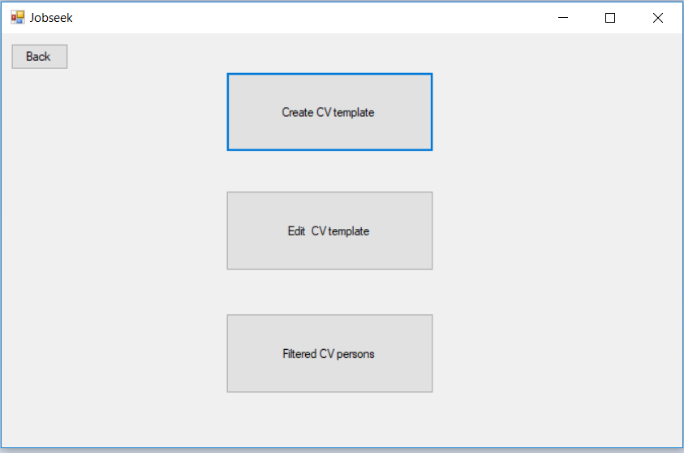

if he choose to create CV he will get the creating template screen and should enter his search parameters:

Also he will get instead of the academic history he will have the option to choose from a predefined list with Educational background

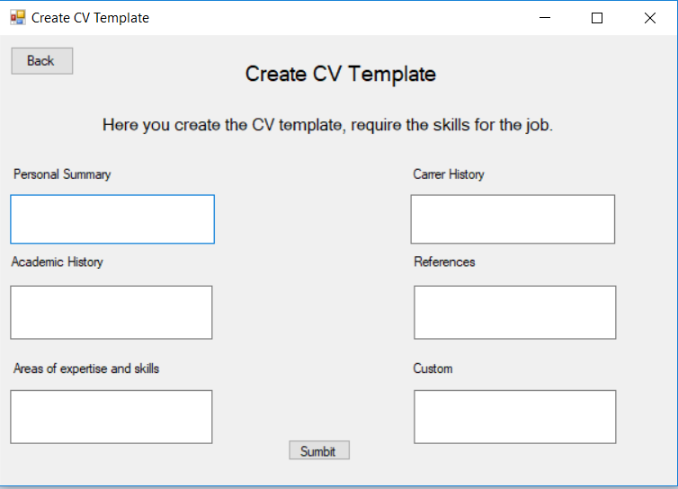

if he want to search CV by other parameters:

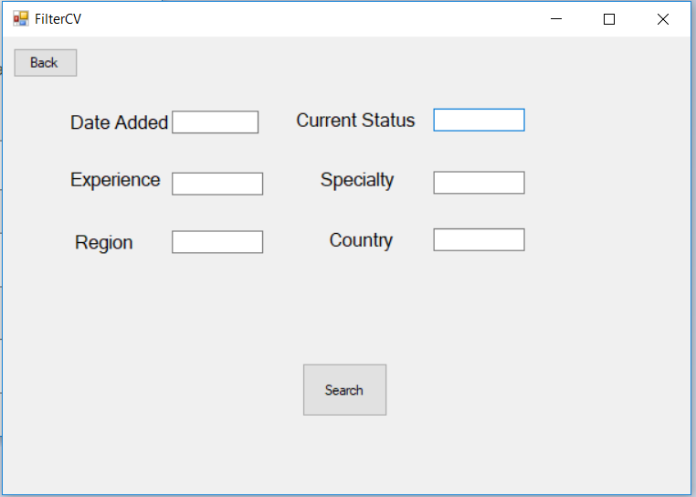

## Hardware Interfaces

*All hardware interfaces will be on the cloud with a huge server and top hardware’s which it will be running.*

*The physical program is managed by the computer and the hardware connection to the database server is managed by the underlying operating system on the computer and the web server.*

*·*

## Software Interfaces

*CV4U communicated to the internet at any moment in order to refresh every time the stock of CVs,the status of the request and new opinions. In parallel the software related to the cloud for backup.*

*The communication between the database and the web portal consists of operation concerning both reading and modifying the data, while the communication between the database and the cloud consists of only modifying operations.*

# System Features

CV4U functional requirements that will built for the product are:

**candidates requirements:**

-register to the system.

-log in the system

-upload CV.

-update CV.

-check CV status(postponed, rejected, hired or under-review)

**HR departments requirements:**

-register to the system.

-log in the system

- possibility to create subfields that sorted by keywords that written in some CV.

- possibility to add an opinion from official professional of the selected field.

- search for candidate according to academic history(experience)

- mark candidate CV as: postponed, rejected, hired or under-review.

- search for candidate according to CV added date

-search for candidate according to CV status

-search for candidate according to expertise

-search for candidate according to country

-search for candidate according to region

## System Feature

**ID: FR1**

TITLE: User registration

DESC: the user should be able to register through the mobile application. The user must provide user-name, password and e-mail address.

RAT: In order for a user to register to the system

DEP: none

**ID: FR2**

TITLE: User log-in

DESC: Given that a user has registered, then the user should be able to log in to the system. The log-in information will be stored on the computer and in the future the user should be logged in automatically.

RAT: In order for a user to log in.

DEP: FR1

**ID: FR3**

TITLE: upload CV

DESC: A user should be able to upload his CV to the system.

RAT: In order for a user to upload files.

DEP: FR1, FR2

**ID: FR4**

TITLE: update CV

DESC: A user should be able to update his CV in the system.

RAT: In order for a user to update his files.

DEP: FR1, FR2,FR3

**ID: FR5**

TITLE: check CV status

DESC: A user should be able to see his CV status in the system.

RAT: In order for a user to check if he rejected, hired.

DEP: FR1,FR2,FR3

**ID: FR6**

TITLE: find a suitable candidate for a position

DESC: A user should be able to enter search parameters and find candidate that appropriate to the specific position.

RAT: In order for a user to seek for appropriate candidates.

DEP: FR1,FR2,FR3

**ID: FR7**

TITLE: possibility to add notes in candidate CV

DESC: A user should be able to add notes on CV so the other decision makers could see.

RAT: In order for a user to see colleague opinions on some candidate.

DEP: FR6

**ID:FR8**

TITLE: mark candidate CV as: postponed, rejected, hired or under-review.

DESC: A user should be able to mark candidate CV as: postponed, rejected, hired or under-review.

So the candidate can check his CV status.

RAT: In order for a user to add status on a CV

DEP: FR6

**ID:FR9**

TITLE: search for candidate according to CV added date

DESC: A user should be able to search for candidate according to CV added date.

so the user check only updates CVs.

RAT: In order for a user to search updated CVs

DEP: FR1,FR2, FR3

**ID:FR10**

TITLE: search for candidate according to CV status

DESC: A user should be able to search for candidate according to CV status.

so the user can seek for postponed, rejected, hired or under-review employees,

RAT: In order for a user to search specific CVs

DEP: FR1,FR2, FR3

**ID:FR11**

TITLE:search for candidate according to expertise

DESC: A user should be able to search for candidate according candidate expertise.

so the user can seek for exact expertise employees,

RAT: In order for a user to search specific CVs

DEP: FR1,FR2, FR3

**ID:FR12**

TITLE:search for candidate according to country

DESC: A user should be able to search for candidate according to candidate country.

so the user can seek for candidates from specific country.

RAT: In order for a user to search specific country

DEP: FR1,FR2, FR3

**ID:FR13**

TITLE:search for candidate according to region

DESC: A user should be able to search for candidate according to candidate region.

so the user can seek for candidates from specific region.

RAT: In order for a user to search specific region

DEP: FR1,FR2, FR3

**ID:FR14**

TITLE:Educational background should be selectable

DESC: A user should be able to select his educational background from a pre-defined dropdown list.

RAT: Select Educational background

DEP: FR3

# Other Nonfunctional Requirements

## Performance Requirements

*Upload time will not exceed 30 minutes.

*Storage of CV’S will not exceed 1 tera.

*After 365 from the last update\create ,The CVs will be deleted,or it will give a notification to being updated until 30 days.

*Must internet connection to access to the database.

## Safety Requirements

Encapsulation - The software is stand alone. therefore only one admin have access to change’s in the code.

At all time the code save in the cloud so when a failure happened or a bug there is a restore option through the cloud.

## Security Requirements

CV4U has security that protect from hacks and unknown entries.

CV4U has huge database and a local backup server that will protect from possible loss or damaged data that could result from the use of the product.

User identity authenticationmust be with is own password.

the private information of the user is protected, safety and allowing only to bodies.

## Software Quality Attributes

Quality of Service – meeting what users actually want, thus maximizing their utility.

the software tested and updated consistently

*\*There will be a support team , which gives a maintenance in period time of maximum 24 hours.*

*\*Every month there will be a major update to software , and they will receive it on time ,and the user doesn't need to do anything about the data or change something its will update the code and the database too.*

*Online Chat in the product site , which gives a 24/7 in the website